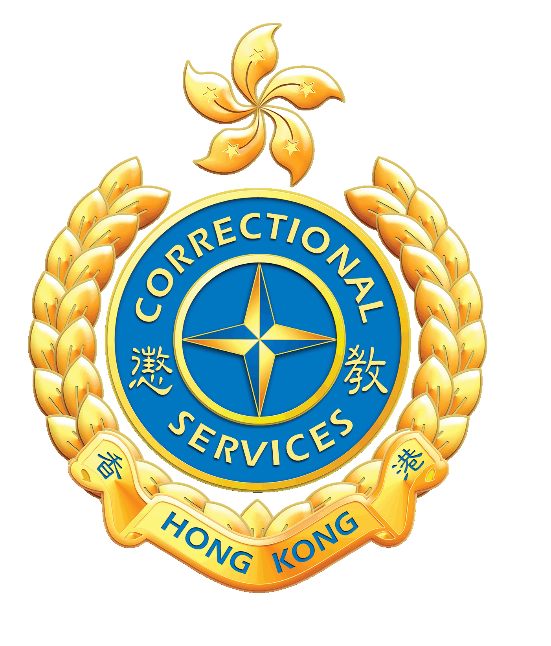
Correctional Services Department
Application Form for Rehabilitation Pioneer Leaders
Office Use Only
Reg No. :________________
Date: / /

Personal Information

Name：(Chinese) (English) Gender：

H.K.I.D. No.： ( ) Date of Birth： / /

Address： E-mail Address：

Contact No.： Mobile no.： （Via. Whatsapp：□ Yes □ No）

School： School Address： Form：

Uniform Group Experience：□ Yes □ No（ Please tick the appropriate） □ > 1 Year □ 1 – 3 Years □ < 3 Years

Name of Uniform Group（If any）： （Year： Rank： Qualification： ）

Do you have any special health conditions, e.g. allergies, asthma or ongoing medical treatment, etc.?

______________________ ________________

Applicant’s Declaration *(Please delete the inappropriate)

I wish to participate in the Rehabilitation Pioneer Leaders, for which I *agree / disagree to abide to the rules and regulations for this activity. I have acknowledged the full content of the activity. My health condition is suitable for such and I am willing to participate under my own risk. I certify that the personal data provided in the application is correct, the information provided may be used for other related purpose and the photos taken during the activity are solely for Departmental use.

Applicant’s signature： Date：

Remarks： | 1. | Information provided in this application will be used for admission of the course and other related purpose.
 | 2. | Applicants reserve the right to access or change the personal information under Personal Data (Privacy) Ordinance. However, these should be made in written form to the designated personnel.

The personal data and other related information provided in the application form will be used by the Department to deal with the application for participating in the activity / course and other related purpose. The provision of personal data and other related information by means of the application form is voluntary. However, we may not be able to process the application if no accurate or adequate data is provided.

Please return the full application via e-mail or the address below:
Address：Rehabilitation Pioneer Project, Flat A, 16/F, Block F, 3 Lok Man Road, Chai Wan, Hong Kong
E-mail Address：rpp@csd.gov.hk Tel no.：2259 3349

