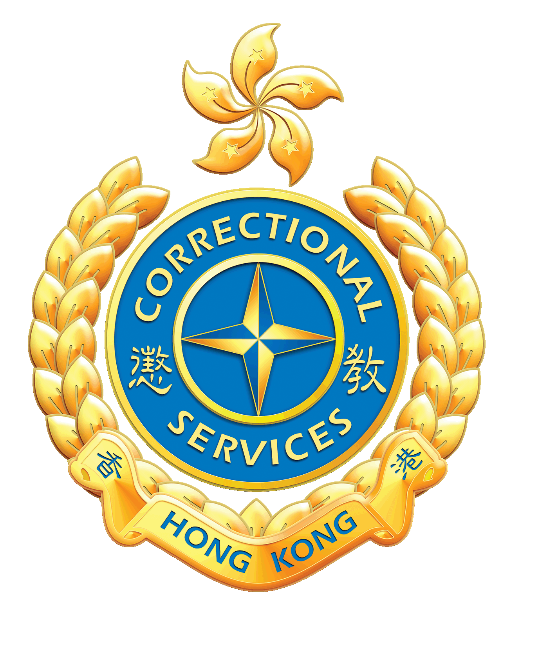
Correctional Services Department
Application Form for Project ReAch
Office Use Only
Reg No. :____________
Date: / /

Part 1: Personal Information
Name: (Chinese) ____________________ (English) ____________________
Gender: ____________________
Have you previously participated in the “Project PATH”? □ Yes □ No (Please tick “✓” the appropriate box)
Hong Kong Identity Card No.: ____________________ ( ) Date of Birth: ____ Year ____ Month ____ Day
Contact Telephone: ____________________ Email: ____________________
Person in Custody Registration No.: ____________________ Education Level: ____________________
Current Employment / Study Status:
□ Employed □ Unemployed □ Studying □ Others: ____________________
Part 2: Preferred Rehabilitation Programmes (you can choose more than one)
(Please tick “✓” the appropriate box)

I. Enhancing National Security Awareness and Understanding of the Rule of Law Series
□ Mainland Exchange Tours
□ Chinese Culture Workshops and Experiential Activities
□ National Security Education Talks and Advanced Courses
□ Visits to Thematic Exhibitions

II. Establishing Correct Values and Strengthening Psychological Resilience Series
□ Volunteer Services
□ Mindfulness and Emotional Regulation Workshops and Experiential Activities
□ Adventure-based Training Programme

III. Identifying Life Direction and Strengthening Family Relationships Series
□ Life Planning Interviews and Talks
□ Work Experience Programmes
□ Family Communication Workshops and Family Fun Days

Part 3: Applicant’s Declaration
- I hereby apply to participate in the “Project ReAch” and understand that some activities may involve physical training or adventure elements. I am willing to bear the associated risks.
- I confirm that the information provided in this form is accurate and correct.
- I understand that all applications are subject to review and selection, and acceptance is not guaranteed.
- I agree that the Correctional Services Department may take photographs or videos during activities for record and promotional purposes.
Applicant’s Signature: ____________________ Date: ____________________

Part 4: Personal Data Collection Statement
- The personal data provided by the applicant will be used for processing the application, communication, activity arrangements, assessing the applicant’s suitability for the programme, and for programme monitoring, review, research, and statistical analysis purposes.
- Provision of personal data is voluntary. If the applicant fails to provide sufficient information, the Department may not be able to process the application.
- The applicant has the right to request access to or correction of personal data contained in this form in accordance with the Personal Data (Privacy) Ordinance.

Remarks
- The Department reserves the right to amend or cancel activities in accordance with operational needs.

Please submit the completed application form by email to “Rehabilitation Unit 3” at ru3_info@csd.gov.hk.

